Q. Full Joins
Query:
select
C1.class_id,
C1.room_name,
S1.sub_name
From classroom C1 LEFT JOIN subject1 S1
ON s1.sub_id=c1.sub_id
UNION
select
c1.class_id,
c1.room_name,
s1.sub_name
From
Classroom c1 Right join subject1 S1
ON S1.sub_id=c1.sub_id;

Screenshot:

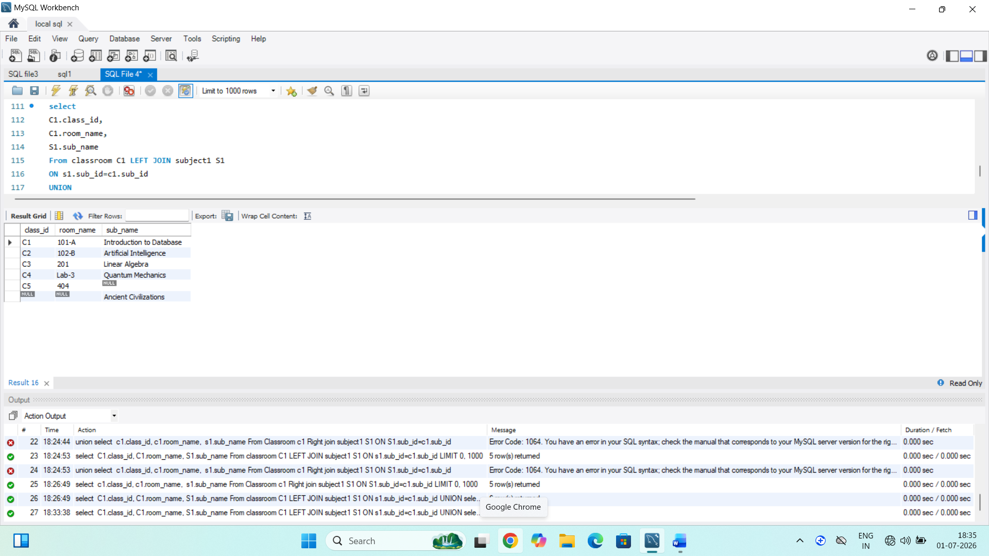

Insights:
1. Union removes duplicate matching rows from the result.
2. NULL where no matching records exists.
3. all records from both classroom and subject1 tables.
4. combines left join and right join to simulate a Full Outer Joins.

